INTRODUCTION TO ADOBE PHOTOSHOP FOR BEGINNERS
(No prior Photoshop experience needed), let’s just have fun being creative…
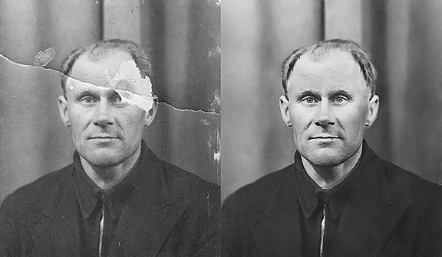

These classes will cover: Photo Retouching | Colour Correction |
Image Enhancing | Image Manipulation | Photoshop effect | Working with Images to produce eye catching posters

Venue: BLACKFRAIRS SETTLEMENT, 1 Rushworth Street London SE1 0RB

TRY ONE OF THESE FREE TASTER SESSIONS
AND
REGISTER FOR THE 5 WEEK COURSE
(For people with mental health needs)

ON Tuesday 29th of April AND Thursday 01st of May 2014
Time: 1:30pm- 3:30pm

Next course starts May 6th 2014

To apply for a place on this or the next course or to find out more please ring Bill or Mannie on 0207 928 9521 or e-mail us:
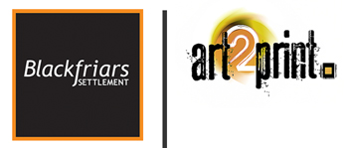
bill.stewart@blackfriars-settlement.org.uk
mannie.onyeje@blackfriars-settlement.org.uk

